**Signature of Cooperation agreement with Italy**

**7Jun**2019

Today the Agency signed a cooperation agreement with the Italian National Safety Authority (ANSF).

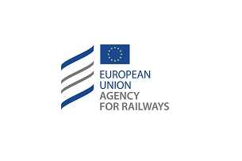

Under the Article 76 (1) of the Regulation (EU) 2016/796 a cooperation agreement was signed today between the Agency of the European Union for Railways (ERA) and the Italian National Safety Authority (ANSF).

A debate on operational modalities to apply the Technical Pillar of the 4th Railway Package with interventions from Josef Doppelbauer (ERA Executive Executive Director), the Director of ANSF – Marco D’Onofrio and the General Director of the Direction for Transports and Infrastructures of the Minister – Enrico Puija was followed by the signature ceremony of the 2 parties.